INSTRUCTIONS TO AUTHORS FOR THE PREPARATION OF PAPERS:
4th INTERNATIONAL CONFERENCE ON ASTRODYNAMICS TOOLS AND TECHNIQUES – 4th ICATT 2010
EUROPEAN SPACE ASTRONOMY CENTRE (ESA/ESAC), MADRID, SPAIN
3 – 6 MAY 2010
Principal Author Name ⁽¹⁾, Co-Author Name ⁽¹⁾, Co-Author Name ⁽²⁾

⁽¹⁾ Affiliation, Complete mailing address (including country), Email:
⁽²⁾ Affiliation, Complete mailing address (including country), Email:

ABSTRACT
The Proceedings of the 4th International Conference on Astrodynamics Tools and Techniques will be published by ESA as publication WPP-308 on CD-ROM.

Authors must deliver their full papers by 15 April 2010 as electronic ‘PDF’ files by using your personal log-in details provided in your notification email.

Please read the following instructions for the preparation of your paper in accordance with ESA’s standards for conference proceedings. Each submission should resemble these instruction sheets in format and style. Start with a concise abstract (limited to 15 lines or 150 words) that summarises the contents of the paper.

GENERAL SPECIFICATIONS
The paper must be prepared in this two-column format and must not be longer than 8 pages.

PAGE LAYOUT
- Paper format: standard A4 (297x210 mm),
- two-column format (8 cm each column),
- margins: top 25 mm, left and right 20 mm,
bottom 37 mm,
- fully justified.

Font:
Text: Times New Roman
Variable: Times New Roman italic
Symbol: True Type Symbol font

Type Size:
Paper title: 12 pt bold (TITLE)
Author(s): 10 pt bold (Author)
Affiliation(s): 10 pt italic (Affiliation)
Normal text: 10 pt (regular text)
Captions: 10 pt italic (Figure…)

Text in tables: 9 pt
Symbols: 10 pt (Ω ≅ φ )
Sub/superscript: 7 pt (x ^{y})

For LaTex users: a set of macros is available on the ESA Publications Conference Proceedings website at: http://www.esa.int/publications/authors

HEADERS AND FOOTERS
Both the header and the footer should be left empty.
Do not add page numbers.

TITLE AND AUTHOR AFFILIATION
The paper title, author(s) name(s), affiliation, complete mailing address and email should be centred at the top of the first page using the fonts and type sizes indicated above. If there are several authors, the complete affiliation should be given for each of them using superscripts ⁽¹⁾ in the authors ⁽²⁾ list to refer to them.

HEADINGS
This sheet has been typeset in accordance with the style to be followed for the headings. Use the decimal system in Arabic figures for the numbering of headings and subheadings. Major (or section) headings are to be in capitals and bold.

Subheadings
Subheadings or subsection headings are to be in lower case with initial capitals and bold font. They should be flush with the left-hand margin, on a separate line.

EQUATIONS
Equations are to be numbered consecutively throughout the paper. Each equation number must be unique. Equations should be centred, with the equation number in parentheses flush with the
right-hand margin of the column. Leave a blank line before and after equations. Always refer to equations by number, as Eq. 1 or Eqs. 3-6, not as ‘above’ or ‘below’.
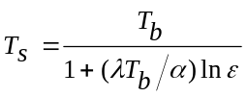 (1)

FIGURES AND TABLES
Figures and tables can extend over two columns if required. Figure captions should be centred below the figures; table captions should be centred above the tables. Use full word ‘Figure 1’ or ‘Table 1’ in the caption. Use the abbreviation “Fig. 1” or “Tab. 1” in the text (even at the beginning of a sentence).
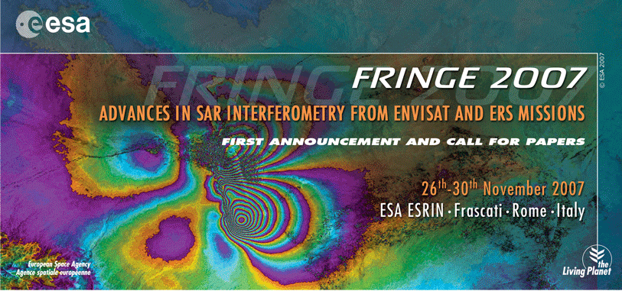
Figure 1. Fringe 2007

ABBREVIATIONS AND ACRONYMS
Define abbreviations and acronyms the first time they are used in the text, even after they have been defined in the abstract. Do not use abbreviations in the title unless they are unavoidable.

REFERENCES
Number citations consecutively in square brackets [1]. Refer simply to the reference number, as in [3]. Do not use ‘Ref. [3]’ or ‘reference [3]’ except at
the beginning of a sentence: ‘Reference [3] was the first …’. The title of the book or of the journal should be in italic script. Further information is available in “How to reference a publication” at:
http://www.esa.int/esapub/conference/references.pdf

Sample References
1. Smith, J.M., Adams, B.A. & Wilson, A. (2002). The Future for Asteroid Exploration. Planet. Space Sci. 285(11), 123-126.
2. Johnson, A.B. & Radice, X.T. (2002). Comets for Beginners, Cambridge University Press, Cambridge, UK, pp103-106.
3. Svalgaard, L. & LeSager, P. (2003). What Heliosesimology Teaches us About the Sun. In Proc. 4th. ISCS ‘Solar Variability as an Input to the Earth’s Environment’ (Eds. H. Lacoste &
H. Xerxes), ESA SP-535 (CD-ROM), ESA Publications Division, European Space Agency, Noordwijk, The Netherlands.

PDF PREPARATION
In order to allow reasonable quality printing, please avoid excessive compression when making your PDF file. Generally, image resolutions should be
600 dpi for monochrome, 300 dpi for greyscale and colour.

VERY IMPORTANT: EMBED ALL FONTS and ensure that the PDF’s security setting is on
‘No Security’.

SUBMITTING THE PAPER
Deadline for submission is
15 April 2010

Papers are to be uploaded on your
personal page
Username and password have been provided by email.
Please contact esa.conference.bureau@esa.int should you have forgotten your log-in details.

The filename must clearly identify the paper. Use the abstract number followed by the name of the main author (e.g. 1752728smith.pdf). Use only lower case.
DO NOT name your file “XXX.pdf”.

Papers must be delivered by 15 April 2010 at the latest, to ensure inclusion in the conference proceedings.
For further information about preparing your paper, please contact:
ESA Conference Bureau
Phone: (+31) 71 565 5005
Email: esa.conference.bureau@esa.int
NOTE: Please do not upload and email the same electronic file. Multiple submissions cause confusion over which file is to be used for publication.

